Parking App Project
- According to my research, I found that there already exists applications that will allow you to pay for parking online, typically by scanning a QR code. Some examples of these applications would be PayByPhone and EasyPark. I found that PayByPhone is introducing a feature that allows users to see lots that have parking available and reserve parking spots ahead of time. However, this is a new feature that is only supported by specific venues and is only available in select states in the United States. This feature also does not allow users to choose specific parking spaces. EasyPark also has a similar feature but it is limited to the same restraints as PayByPhone. In contrast to these applications, my application will have the ability to show users exactly which parking spots are available in certain parking garages. This will also make it so that parking availability predictions within the app are more accurate.

- We acquired this project from the office of Harris County. They saw a need to facilitate parking and improve availability for their citizens. WE ARE $oftware ¢orp was chosen out of a selection of various corporations due to its unlimited resources and budget. ParkingWizard was then created to find a solution to this problem. We want to help users be able to more accurately see available parking and clear prices throughout the city. The software that we are hoping to build will allow users to find available parking garages on a map, see which specific spots are available within those garages, see accurate prices, and even be able to reserve a parking spot online.

Use Cases
  - Creating an account
Primary Actor: User
Goal: Allow new user to create an account on the application.
Precondition: User does not already have an existing account
Steps:
1. User selects “Sign Up”
2. User enters their email and creates a password
3. User verifies their account via verification link sent to their email
Postcondition: User has an account
  - Logging in
Primary Actor: User
Goal: Allow existing user to access their account
Precondition: User has an existing account
Steps:
1. User selects “Log in”
2. User enters the email and password they used to create the account.
3. User selects “Log in” again at the bottom of the page
Postcondition: User successfully logs into their existing account
  - Saving payment methods onto the user account
Primary Actor: User
Goal: Allow for users to save payment methods onto their account for future transactions
Precondition: User has an account, is logged in, and their payment method is valid
Steps:
1. User logs into their account
2. User goes to the “My Account” page
3. User selects “Payment Methods”
4. User selects “Add Payment Method”
5. User enters valid card information
6. System validates and saves the card information onto user account
Postcondition: Payment method is successfully saved onto the user account
  - Searching for a specific location in the search bar on the map page
Primary Actor: User
Goal: Allow for user to find the location they are looking for in the map page
Precondition: User has an account, user is in the map page
Steps:
1. User clicks on the map page
2. User clicks on the search bar at the top of the map page
3. User enters a specific & valid location address
4. User presses “Search”
5. System processes the query
6. System displays the location on the map
Postcondition: The location that was searched for shows on the map
  - Viewing garages that have available parking
Primary Actor: User
Goal: Allow users to see which garages have parking spots available
Precondition: User has an account and is in the map page
Steps:
1. User scrolls through different map areas.
2. System identifies garages with available space
3. System shows user said garages
Postcondition: User is able to identify available parking garages
  - Viewing specific parking spaces within those garages
Primary Actor: User
Goal: User
Precondition: User has selected an available parking garage
Steps:
1. User selects an available garage
2. System accesses available parking spot information
3. System displays said information
Postcondition: User is able to view specific spaces within the garage they selected
  - View pricing for different garages from the map page
Primary Actor: User
Goal: Allow users to view prices to park in different garages
Precondition: User is in the map page
Steps:
1. User scrolls through the map page
2. System pulls pricing information from the garages within the user’s current search area
3. System displays said information
Postcondition: User is able to view pricing information for different garages at once
  - View time limits for parking spots in different garages
Primary Actor: User
Goal: Allow users to see how much time they can park in a garage for
Precondition: User has selected a parking garage
Steps:
1. User selects parking garage
2. System pulls up any time constraint information for that garage
3. System displays the information it pulled
Postcondition: User is informed of the time limit for the garage that they selected
  - Compare amount of available parking spots within different garages.
Primary Actor: User
Goal: Allow users to compare availability among different parking garages
Precondition: User is in the map page, user has selected multiple garages
Steps:
1. User selects various garages
2. System pulls up availability for all selected garages
3. System displays information it pulled for all of the garages
Postcondition: User is able to compare availability between different garages
  - Reserve parking spaces
Primary Actor: User
Goal: Allow users to reserve available parking spots
Precondition: User is logged into their account, selected garage has availability, and user has selected a specific parking spot
Steps:
1. User selects a garage
2. User selects parking space
3. User selects reservation time
4. System displays reservation details for user confirmation
5. User confirms the information
Postcondition: A parking space is held for the user for a short period of time until payment is received
  - Pay for said parking spaces
Primary Actor: User
Goal: Allow users to pay for parking spaces within the garage they selected
Precondition: User is logged in, user has selected a parking reservation, and they have a valid payment method
Steps:
1. User reviews the reservation method that was generated in the previous use case
2. User selects a payment method
3. System validates payment information
4. Payment provider processes transaction
5. System gives user payment confirmation
Postcondition: User successfully pays for their parking reservation
  - Receive directions to get to the reserved parking garage.
Primary Actor: User
Goal: Allow user to receive directions to get to their parking reservation
Precondition: User has a parking reservation
Steps:
1. User accesses their parking reservation
2. User clicks “Get Directions”
3. User selects preferred navigation platform (Google Maps, Apple Maps, Waze, etc)
3. System pulls the parking garage’s location information
4. System launches the preferred navigation platform with the parking garage location pulled up
Postcondition: User is able to receive directions to their parking garage
  - View reservation receipts
Primary Actor: User
Goal: Allow users to access existing receipts for their parking reservations
Precondition: User is logged into their account and has reserved a parking garage in the past
Steps:
1. User opens their reservation history page
2. User selects a reservation that was paid for and confirmed
3. System pulls the receipt associated with that reservation
4. System displays said receipt for the user
Postcondition: User is able to view the receipt associated with a specific transaction
  - Share reservation with other people
Primary Actor: Driver
Goal: Allow users to share their reservation information with other people
Precondition: User has a confirmed reservation
Steps:
1. User accesses their reservation
2. User clicks “Share”
3. System generates a sharable version of the selected reservation
4. User selects a sharing method
Postcondition: User is able to share their reservation information with other people
  - View all past reservations made in the account
Primary Actor: User
Goal: Allow user to view previous paid reservations associated with their account
Precondition: User is logged in and has made a reservation before
Steps:
1. User clicks “My Account”
2. User clicks “Reservation History”
Postcondition: User is able to view their reservation history

Work Breakdown Structure
1. Project Planning
1.2 Define Project Scope
1.3 Develop Project Schedule
1.4 Develop Project Budget
1.5 Identify Project Risks
2. Project Coordination
2.1 Team Coordination
2.2 Progress Meetings
2.3 Status Reporting
3. Project Documentation
3.1 SRS Documentation
3.2 Project Management Documentation
3.3 Final Project Documentation
4. Stakeholder Analysis
4.1 Identify Drivers
4.2 Identify Parking Operators
4.3 Identify City Transportation Stakeholders
4.4 Identify Payment Providers
4.5 Identify System Administrators
5. Requirements Elicitation
5.1 Gather Driver Requirements
5.2 Gather Operator Requirements
5.3 Gather Administrative Requirements
5.4 Identify External Integration Requirements
6. User Interface Design
6.1 Mobile Application Design
6.2 Web Application Design
6.3 Map Interface Design
6.4 Reservation Interface Design
7. System Architecture
7.1 Backend Architecture
7.2 Database Architecture
7.3 API Architecture
7.4 Security Architecture

Backlog (HWK 3)
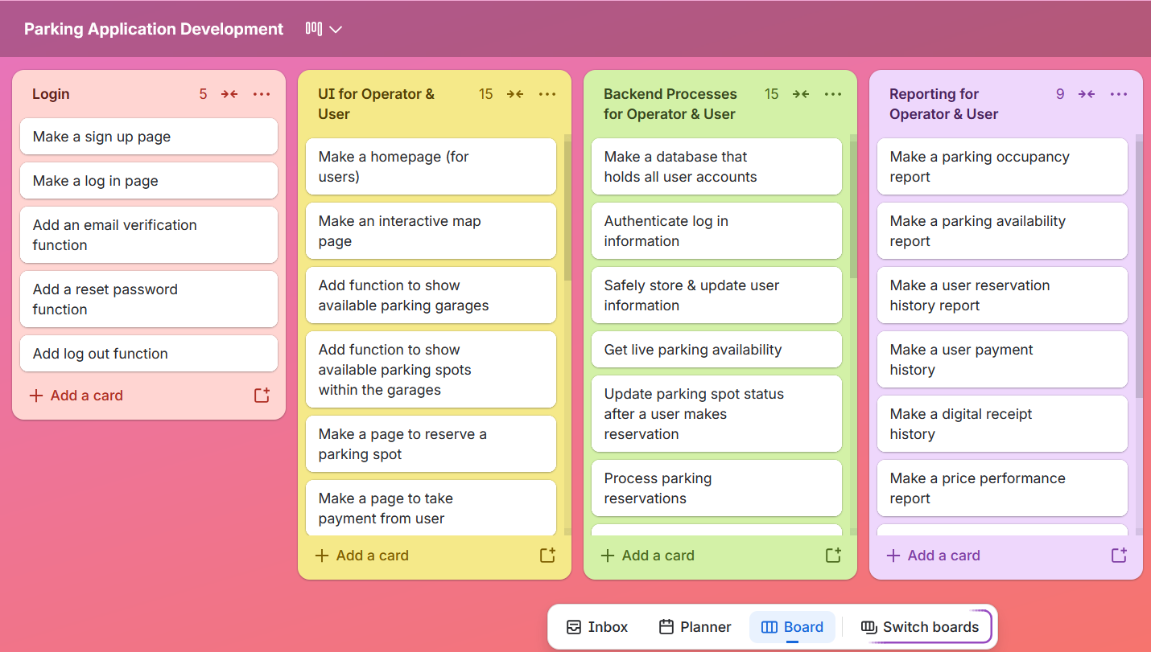
Backlog organization:

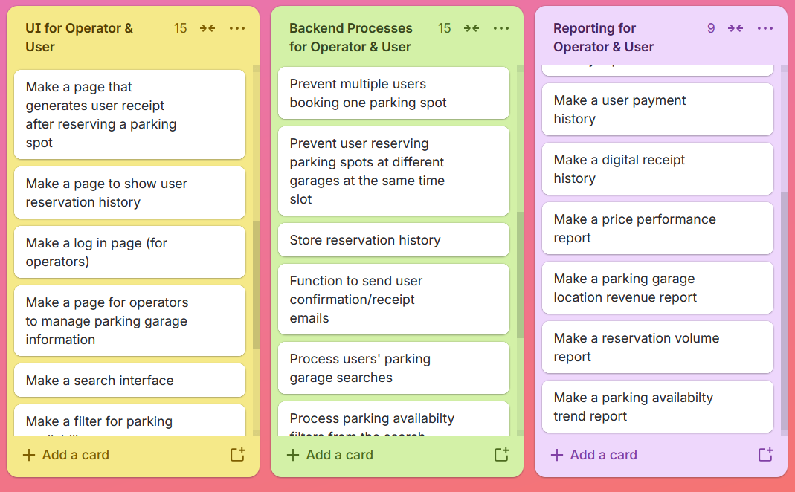
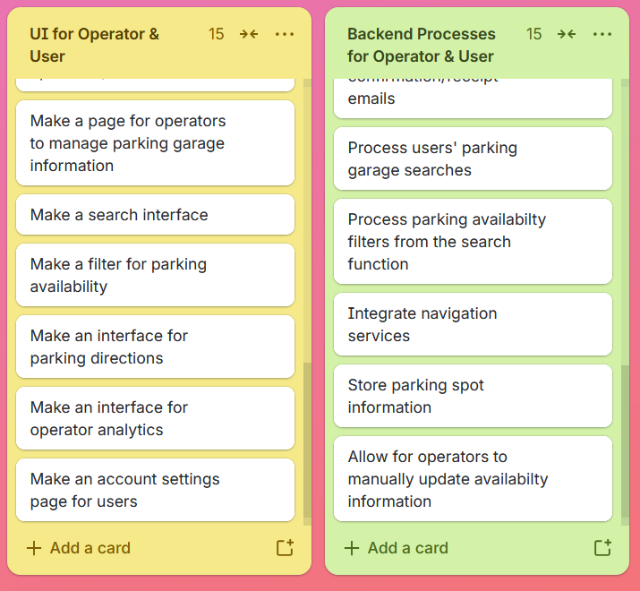
Sprint planning: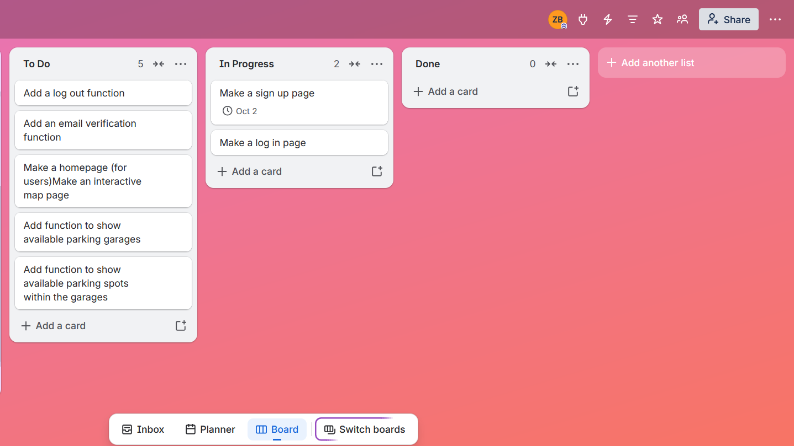
Risks (HWK 4)
Some technical risks that I can foresee taking place:
- Security issues
- Real time availability problems
- Third party integration issues
- Database issues
Some schedule issues that I can foresee taking place:
- Testing delays
- Development takes too long
- Work overload in one sprint
- Third party delays
Some financial issues that I can foresee taking place:
- Cost to implement third party services
- Maintenance costs
- More resources needed during development
- Infrastructure costs
Some people issues that I can foresee taking place:
- Communication issues
- Differences in skill levels
- Limited availability
- Team members not getting along
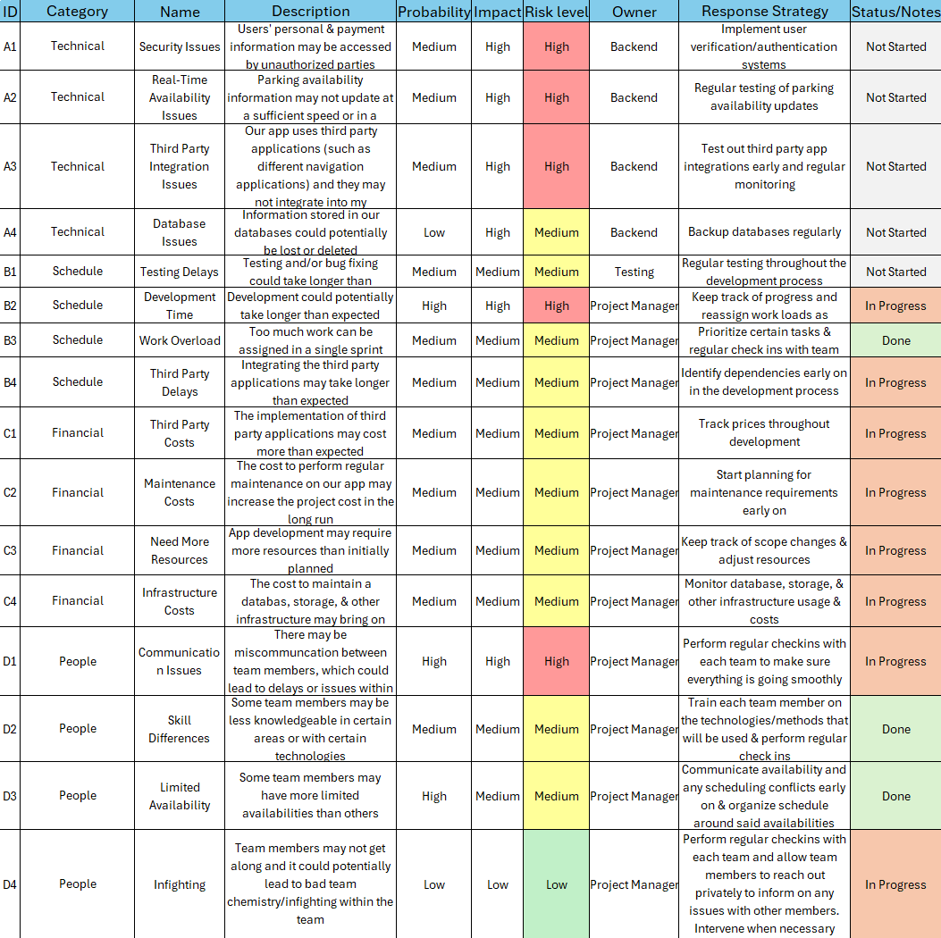
Risk Register:

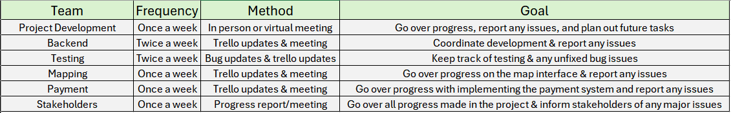
Communication Plan:

Homework 5
Roles & Resources
Developers: Amina Turner; Senior (10 years of experience); 100%
Hayden Choi; Senior (8 years of experience); 100%
Ibrahim Hadid; Senior (13 years of experience); 100%
Project Manager: Freddy Lee; Senior (15 years of experience); 50%
Quality Assurance: Andrea Martinez; Junior (2 years of experience); 50%
Stanley Boyle; Mid Level (3 years of experience); 50%
UX: Ameer Ali; Mid Level (4 years of experience); 75%
DevOps: Hector Ortega; Senior (8 years of experience); 50%
Nicole Cuevas; Senior (10 years of experience); 50%
Business Analyst: Jennifer Bodine; Mid Level (5 years of experience); 80%
Product Owner: Brandon Nguyen; Senior (10 years of experience); 100%
Subject Matter Expert: Victoria Goodwin; Senior (13 years of experience); 25%
Resource & Cost Plan (Bottom-Up):
Parking Application (12 people, 5 months) – worked bottom-up:
Assumptions:
- PM: 1 * (800 hours * $50/hr) = 1 * 40,000 = 40,000
- Developers: 3 * (800 hours * $70/hr) = 3 * 56,000 = 168,000
- QA: 2 * (800 hours * $40/hr) = 2 * 32,000 = 64,000
- UX: 1 * (600 hours * $50/hr) = 1 * 30,000 = 30,000
- DevOps: 2 * (800 hours * $60/hr) = 2 * 48,000 = 96,000
- Business Analyst: 1 * (800 hours * $45/hr) = 1 * 36,000 = 36,000
- Product Owner: 1 * (800 hours * $55/hr) = 1 * 44,000 = 44,000
- Subject Matter Expert: 1 * (100 hours * $40/hr) = 1 * 4,000 = 4,000
Labor Subtotal: 40,000 + 168,000 + 64,000 + 30,000 + 96,000 + 36,000 + 44,000 + 4,000 = $482,000
Infrastructure & Other Costs = Cloud $6,000/month * 5 = $30,000; Third Party Applications $3,000; Licenses $10,000; Security $30,000; Training $5,000; Hardware $7,500 -> subtotal = $85,500
Overhead/Benefits (30% of labor) = 0.30 * $482,000 = $144,600
Total Before Contingency = $482,000 + $85,500 + $144,600 = $712,100
Contingency (15%) = 0.15 * $712,100 = $106,815
Grand Total = $712,100 + $106,815 = $818,915 (~819K)
Cashflow:
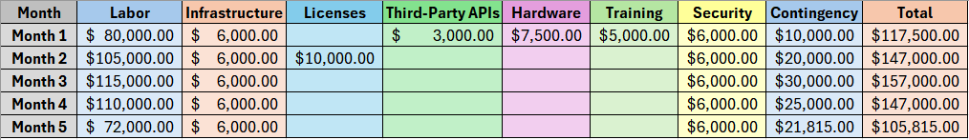
RACI Matrix:
